Bioleaching Modelling [Sequential] — Process Optimisation
With the current bioleaching process, it takes 72h to leach 46% of gold from a 10% pulp density in a given litre of thiosulphate. This process, while desirable, is not enough for an effective process. Thus, this document explores the various ways mechanical properties can be optimised for high gold leaching yield.

Stage 3 Optimisation

Optimisation 1: Crush Size
Crush size was swept from 0.25 to 10 mm at 10% w/v pulp and 0.094 M thiosulphate (Figure 1).
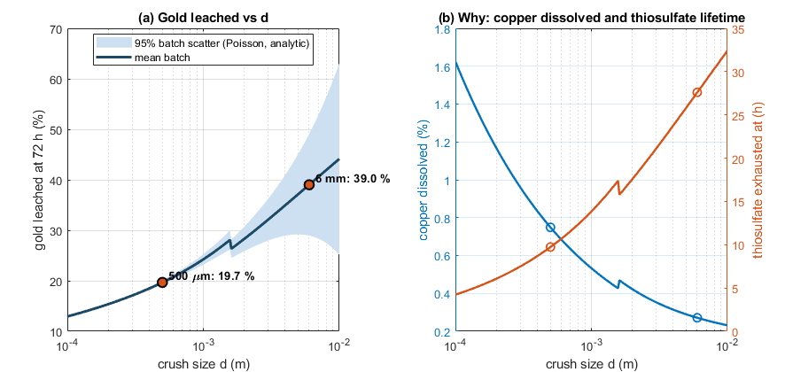
Figure 1
Looking at trends in Figure 1a, it seems that gold leaching decreases with particle size. The main impact of crush size is copper particle size. Gold is a 0.5 μm plated film, so crushing splits the board but will usually leave the gold surface unchanged. Meanwhile, copper is a bulk metal and thus shrinks as it dissolves, and its surface area is linked to crus h size. Thus, finer crushing exposes more copper, which dissolves faster and produces more Cu(II). Cu(II) destroys thiosulphate, so the leachate solution runs out faster. Thus, less gold is leached.
When 72h is used as a time frame, coarser particles are always better, because, as crush size increases, less copper is dissolved and thus there is more thiosulphate available for gold leaching. A 6 mm crush size leaches nearly 40% of gold in solution.
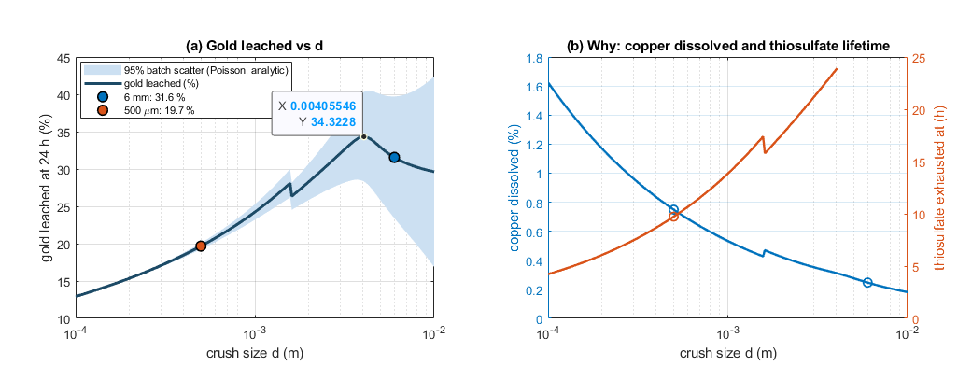
Figure 2
However, if a 24h timeframe is used, there is a global optimum crush size of ~ 4 mm that recovers around 34% of leached gold.
Thus, on its own, finer crushing lowers gold per batch unless. The hardware choice of less than 500 μm for a crush size is thus not defensible, when looking only at the impact of crush size on gold leaching. However, finer crush sizes make each stage faster, which may work well.

Optimisation 2: Thiosulphate Charge
The stage 3 thiosulphate charge was swept from 0.01 M to 1.0 M with 6 mm spheres at 10% w/v pulp.
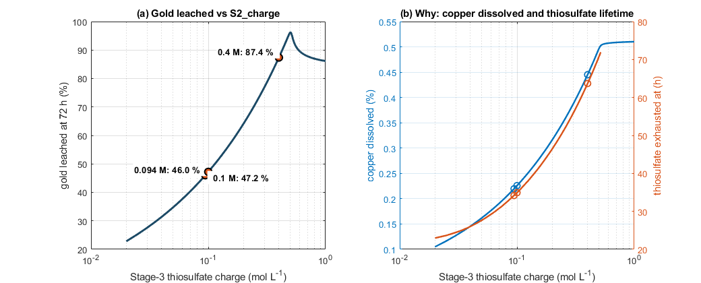
Figure 3
With a batch time of 72h, creasing amounts of thiosulphate increases the gold recovered until a peak is reached. Then it falls. This makes sense, as at greater thiosulphate concentration, more thiosulphate leaches more gold. However, after 0.5 M, recovery falls. This is because, with excess thiosulphate, Cu(II) is turned back into Cu(I) almost immediately, and thus the Cu(II) oxidant route shuts down.
Literature from gold leaching says that the ideal thiosulphate concentration is 0.1 to 0.4 M. Above it, thiosulphate breaks down products such as sulphur and polythionates foul gold surfaces. Thus, the ideal concentration is 0.4 M for 72h. With a batch time of 24h, the ideal concentration is 0.07 M, with a peak recovery of 33%.

Optimisation 3: Pulp Density
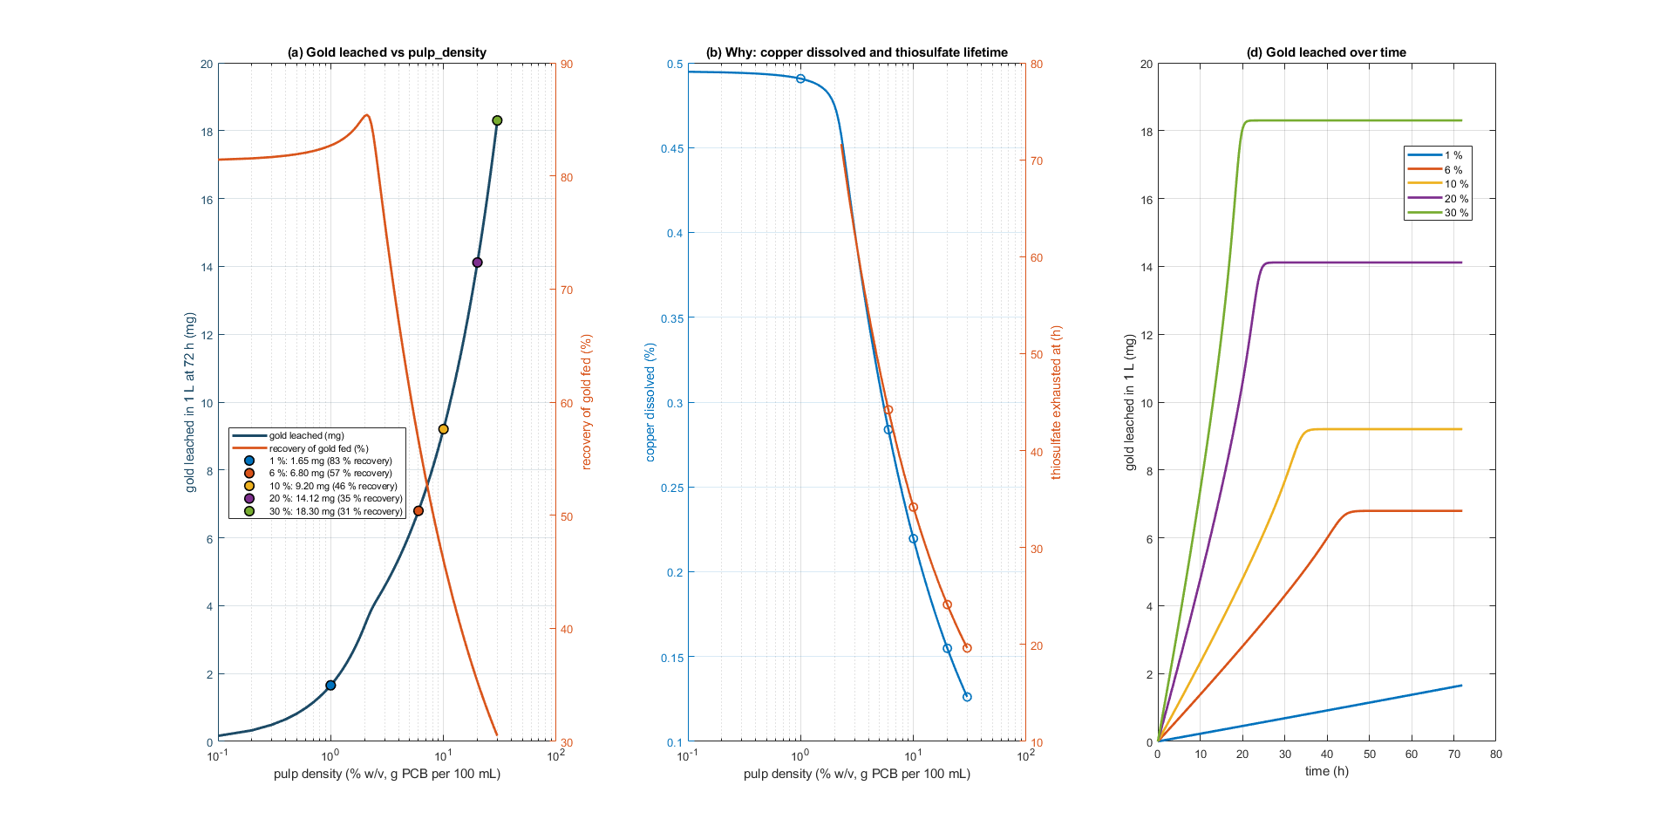
Figure 4
Pulp density was swept from 1% to 40% w/v with 6 mm spheres and 0.094 M thiosulphate. Golder and copper scale with the mass of the board.
Looking at the curves for 72h, it seems that high recovery with pulp density is misleading. Raising pulp density lowers the 72h recovery, yet the mass of gold leached actually rises with pulp density. A 1% batch looks excellent using recovery but produces almost nothing. Thus, recovery is not a good judge for the effectiveness of pulp density.
Batch time was also explored to see if it could be used to determine the best pulp density for gold leaching.

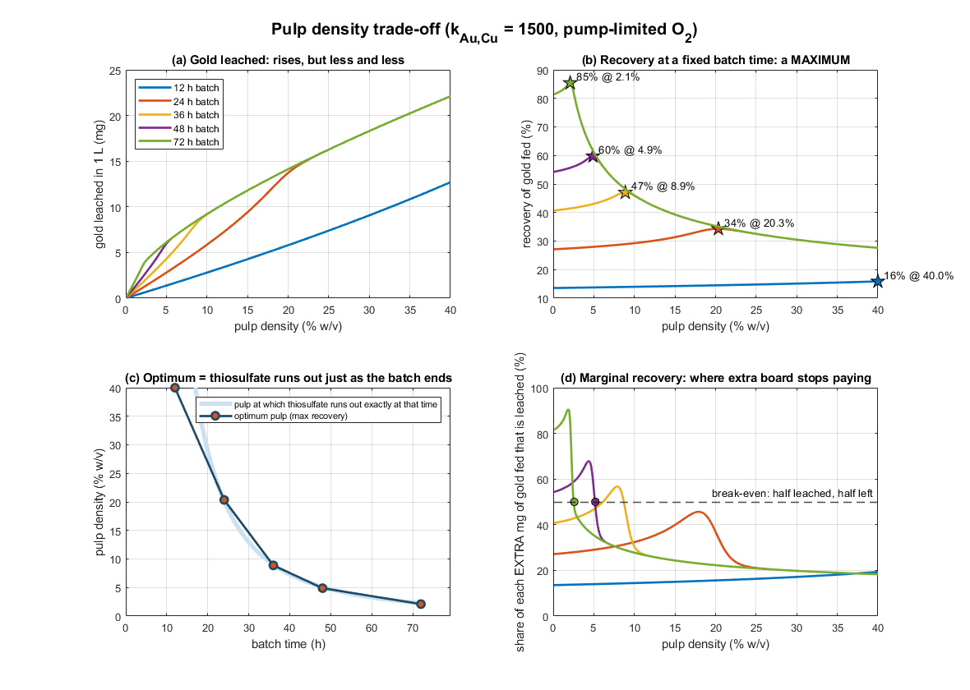
Figure 5
As see in Figure 5b, for a fixed batch time, there is a best pulp density against recovery, and it falls as batch time rises. Thus, for a longer batch time, a smaller pulp density is recommended and vice versa. However, for short, heavily loaded batches, most of the gold is left in solids. Thus, any short-batch design will needs solids to be re-leached in many stages.
Since the gold leached per batch time is still a trade-off of recovery vs gold leached, the marginal recovery was calculated with the equation below to see if there are any diminishing returns.
$$Marginal Recovery=\frac{∆Gold leached}{∆ Gold fed}×100\%$$
With this equation, a marginal recovery of 50% represents a break-even. It means more gold was leached than left behind as a solid. As seen in Figure 5d, with a 72h batch time, marginal recovery falls below this break-even point at 2.6% w/v, which is still not a good judge. Using a 24h batch time, marginal recovery never reaches 50%, as the batch is limited by time. However, it peaks at 45.64% around 18.055% w/v.

Interactions Between Parameters
Since each parameter has optimum values with fixed parameters, the various parameters were varied with each other to find optima that match multiple parameters for operational efficiency.

$$Pulp Density ×Thiosulphate Concentration$$
Another way to characterise optimise pulp density is the one at which thiosulphate runs out as batch time ends. If there is less board than this, thiosulphate is left over and leaching capacity is wasted. If there is more, the extra copper produces Cu(II), which destroys thiosulphate.
Using this metric, as seen in Fig 5c, the best pulp density is 40% for 12h, where thiosulphate runs out in ~17h; 20.35% for 24h, where thiosulphate runs out at ~23.9h; 8.88% for 36h, where thiosulphate runs out at 36.2h; 4.89% for 48h, where thiosulphate runs out at 49h.
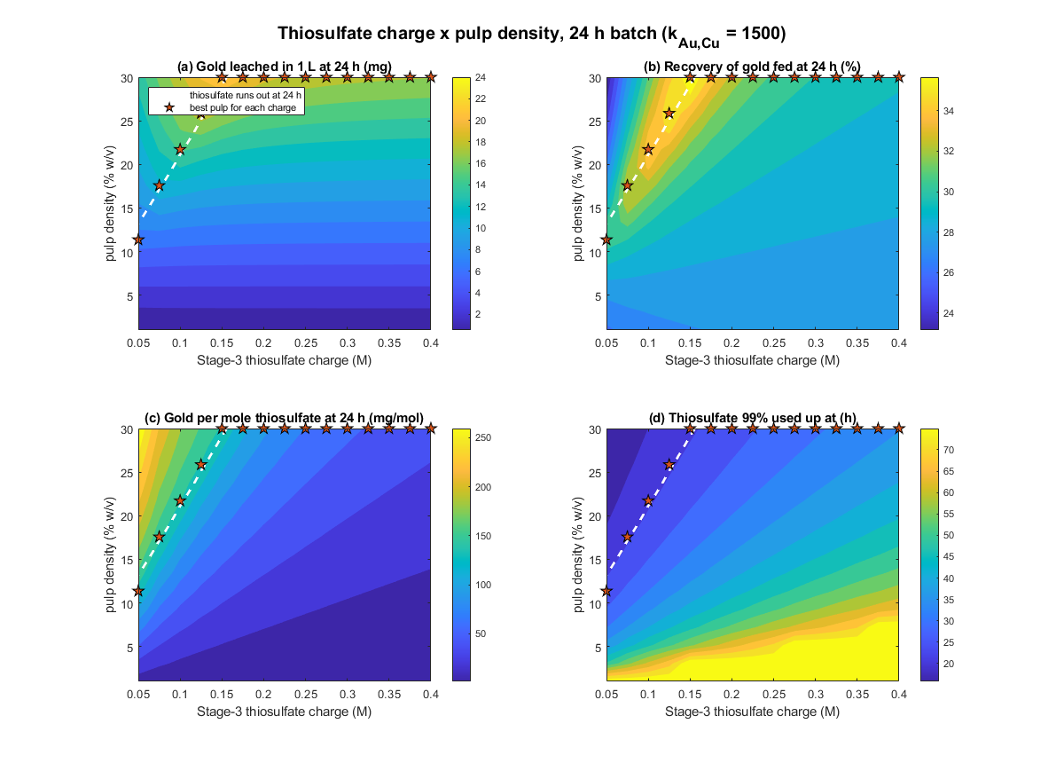
Mapping both pulp density and thiosulphate together helps find the mass of board each mole of thiosulphate can serve. For example, in a 24h with 6 mm particles, this is roughly 1.95 kg per mole of thiosulphate (from a range of ~1.6 to ~2.3 kg across 0.05 to 0.4 M). These ratios are important for scaling up for scaled-up industrial processes.

$$Pulp Density×Crush Size$$
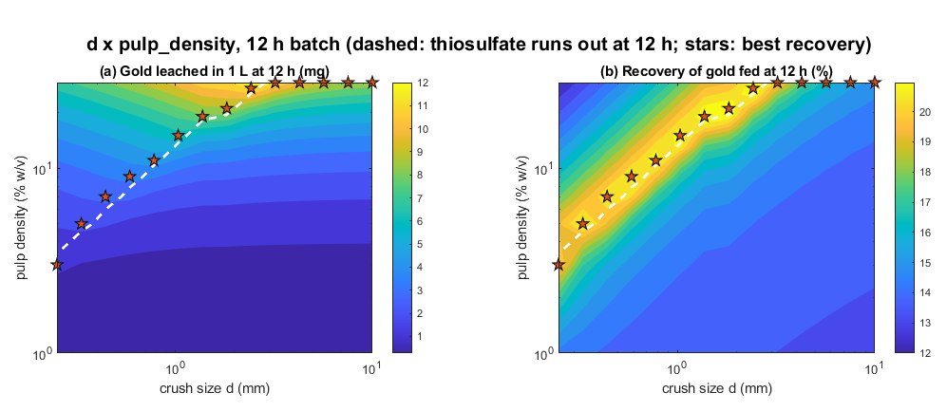
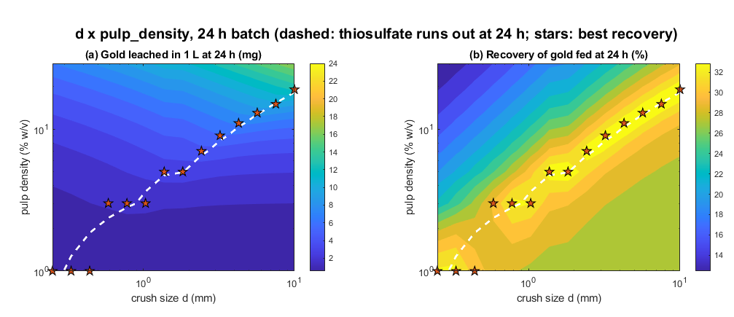
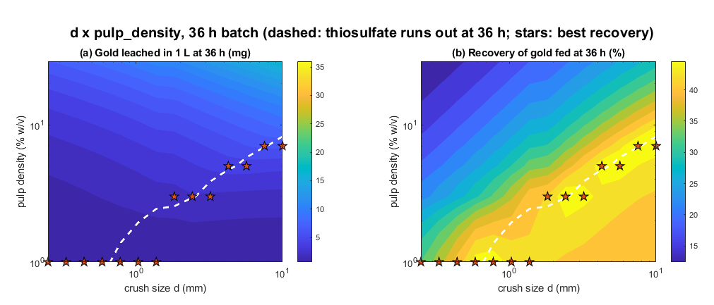
At a fixed thiosulphate charge, the best pulp density seems to rise in proportion to crush size, with a roughly linear curve for all batch times from between 12h to 36h. Thus, it can be assumed that doubling the particle diameter roughly doubles the pulp density i.e. the mass of board loaded per litre. Looking at the scales, the amount of gold leached at each optimum increases with crush size. However, that is only because more board, and thus more gold is loaded.
Away from the optimum, gold recovery and the amount of gold leached falls on both sides. If the pulp density is too low, there is little copper surface area to generate Cu(II), so gold leaches slowly. If the pulp density is too high, then thiosulphate runs out early and leaching stopes
When tracking gold recovery, it seems to stay constant at the best pulp density for every crush size. The reason may be due to copper surface area. In the crush size and pulp density maps, the best pulp densities divided by $d×ψ$ came to about 37-40g/L per mm at every crush size. That near-constant shows that copper surface area is a controlling variable with this parameter interaction. Since gold is a thin plate, crushing changes the number of gold-bearing fragments, not the total area of gold. Copper, however, is a bulk metal spread throughout the board, and thus a smaller crush size exposes more copper for leaching. Thus, copper surface area per litre depends on how much board is loaded and how finely it is crushed.
$$Copper surface area per litre ∝pulp density ÷(d×ψ)$$
And the best pulp density is the one that provides exactly enough copper surface area for thiosulphate to run out as the batch ends. At this optimum, recovery is fixed by batch time and thiosulphate concentration. A larger thiosulphate charge can tolerate more copper while leaving more available for gold leaching, while longer batch times increase gold recovery.

$$Thiosulphate Concentration ×Crush Size$$
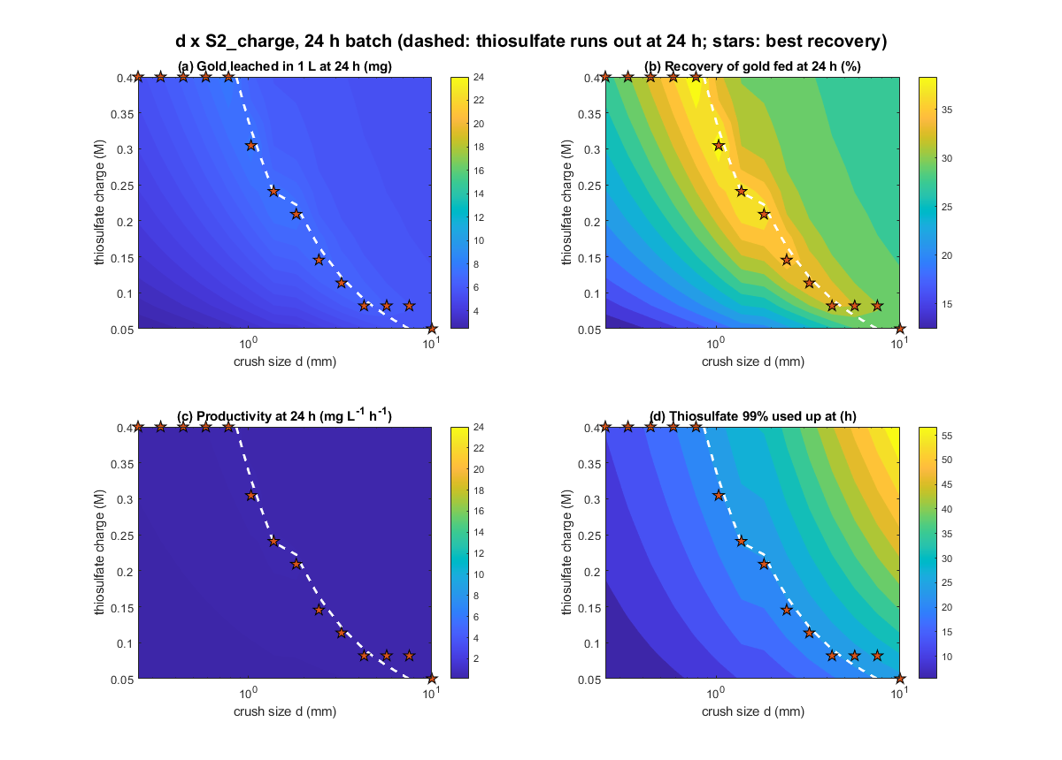At a fixed pulp density, it seems finer crush sizes need a greater thiosulphate concentration. At 24h and a fixed 10% w/v, the best thiosulphate concentration is ≥ 0.4 M for 0.25 mm crush sizes, 0.3 M for ~1 mm crush sizes, 0.21 M for ~1.8 mm crush sizes, 0.08 M for 5.7 mm crush sizes, etc.
The reason is the same as for pulp density: copper surface area. At a fixed pulp density, a finer crush size exposes more copper surface area per litre. At a fixed pulp density, a finer crush size exposes more copper per litre, producing Cu (II) faster and thus depleting thiosulphate faster. Thus, a finer crush size needs a large thiosulphate concentration to last the whole batch time.
Looking at a 24h batch time, the best charge lies above the 0.4 M limit. Therefore, fine crushes cannot reach their optimum within the given literature range. Their thiosulphate runs out early.
Looking at the recovery stage, it seems fine crushes lead to a higher gold recovery. However, this is not due to the particle sizes. Smaller particle sizes need larger thiosulphate concentrations to work at their optimum. Thus, there is more thiosulphate available for gold leaching, hence the higher recovery for a given batch time.

$$Pulp Density ×Thiosulphate Concentration ×Crush Size$$
Across all three interactions, it seems that the optimum times for all three settings align best with where thiosulphate runs out as a batch time ends, for 24h. Looking at all the curves where, the dotted lines represent the times thiosulphate runs out, the following trends can be identified.
Ratio | Proportion
$$Pulp Density ×Thiosulphate Concentration$$ | $$Best pulp density ∝ [S₂O₃²⁻]$$
$$Pulp Density×Crush Size$$ | $$Best pulp density∝d×ψ$$
$$Thiosulphate Concentration ×Crush Size$$ | [S₂O₃²⁻] × d × ψ ≈ constant
Best Pulp Density | Best pulp density ∝ 1 ÷ t²

From these, the general equation for the best pulp density can be derived as the following
$$Best pulp density∝[S₂O₃²⁻]×d×ψ÷t^{2}$$
$$Best pulp density=C×[S₂O₃²⁻]×d×ψ÷t^{2}$$
C can be calculated using one known point. Ideally, using t = 24 h, [S₂O₃²⁻] = 0.094 M, d = 6 mm, ψ =1 (from Figure 5b), C can be calculated.
$$203.493=C×0.094×6 mm×1÷{\left(24\right)}^{2}→C≈2.078226×{10}^{5}$$
Checking this against other cases, the errors are the following.
Case | Prediction | Actual | Percentage Difference
Best pulp density, 36h, 0.094 M, 6 mm | 9.044% | 8.878% | -1.87%
Best pulp density, 48h, 0.094 M, 6 mm | 5.097% | 4.888% | 4.10%
Best pulp density$÷(d×ψ)$, 24h, 0.094 M | 33.915 | 33.9155%

From this, it can be said that the model is mostly accurate. Thus, the best recovery equation can be fitted based on the results of the optimum pulp density equation in the following form.
$$Recovery\left(\%\right)=a×t_{out}+b×\left[S_{2}O_{3}^{2-}\right]+c$$
When the equation is fitted by least squares to every model run in the 72h crush size by thiosulphate maps, the constants are found to be a = 1.15, b = 22, and c = 6 with an R² = 0.998 and a median error of 0.5%.
Using that, the following parameters can be assumed to calculate the maximum gold recovery. According to literature and practical limits, thiosulphate concentration can be capped at [S₂O₃²⁻] = 0.4 M, and pulp density can be capped at 30% or 300 g. Batch time t can be capped at t = 24h too. C was recalculated from [S₂O₃²⁻] = 0.4 M to get a value of $1.69022×{10}^{5}$. From there, the best crush size can be calculated by rearranging the best pulp density equation.
$${pulp}_{BEST}=C×\left[S_{2}O_{3}^{2-}\right]×d×ψ÷t^{2}→d×ψ=\frac{{pulp}_{BEST}×t^{2}}{C×[S₂O₃²⁻] }$$
$$d×ψ=\frac{300×{24}^{2}}{1.69022×{10}^{5}×0.4 }=2.55588 mm$$
After iteratively calculating, the final diameter is around approximately $d≈3.4 mm$ with $ψ≈0.754$. and a recovery of 42.4%.
Using the Hardware team’s crush size of 500 μm and capping some parameters based on realistic limits, the batch time needed to leach as thiosulphate finishes can be calculated once again using the pulp density equation.
$${pulp}_{BEST}=C×\left[S_{2}O_{3}^{2-}\right]×d×ψ÷t^{2}→t=\sqrt{\frac{C×\left[S_{2}O_{3}^{2-}\right]×d×ψ}{{pulp}_{BEST}}}$$
With everything else fixed, the optimum batch time is 10.62h, with a recovery of 27.01%.
Reaching 100% Through Re-Leaching
No single optimised batch exceeds 40%. Thus, the same solids will need to be re-leached with fresh thiosulphate in stages to fully extract all gold. Gold film area and copper surface area barely changes between stages, so each stage leaches about the same amount. Thus, the number of stages needed is therefore about 100 % ÷ the single-stage recovery, and each stage ends when its thiosulfate runs out.
Using the following constants, the following designs were calculated: $d≤500 μm, pulp=300 {gL}^{-1}$. The following use case table was derived, using predicted C values from this lookup table.
S (M) | 0.05 | 0.1 | 0.2 | 0.3 | 0.4
C used | 2.5×10⁵ | 2.0×10⁵ | 1.8×10⁵ | 1.7×10⁵ | 1.7×10⁵

[S₂O₃²⁻] (M) | Pulp (% w/v) | Average Gold per stage (mg L⁻¹) | Recovery per stage (%) | Stage Length (h) | Stages | Total time (h) | mg Au per mol S₂O₃²⁻ | mg Au L⁻¹ h⁻¹
0.05 | 30 | 6.68 | 11.1 | 5 | 9 | 45 | 133 | 1.33
0.094 | 30 | 8.77 | 14.6 | 6 | 7 | 42 | 91 | 1.43
0.094 | 10 | 3.88 | 19.4 | 10 | 6 | 60 | 35 | 0.33
0.15 | 30 | 10.50 | 17.5 | 7 | 6 | 42 | 67 | 1.43
0.25 | 30 | 12.78 | 21.3 | 9 | 5 | 45 | 48 | 1.33
0.4 | 30 | 15.16 | 25.3 | 11 | 4 | 44 | 38 | 1.36
0.4 | 6 | 4.83 | 40.2 | 24 | 3 | 72 | 10 | 0.17

The best overall design is therefore 0.094 M thiosulphate, 30 % w/v pulp density and a 0.5 mm crush size, run as seven 6 h stages (42 h in total). It ties for the fastest time and highest productivity (1.43 mg L⁻¹ h⁻¹), and is second only to 0.05 M in thiosulphate efficiency (91 mg Au per mol). Unlike the other charges, it uses the Stage 2 product as made, with no concentrating or diluting step.

